Note:
A policy = rule set by the organization.

Perfoming here as an administrator:

Developing a security policy:
Requirement gathering

Nist sp 800-53:
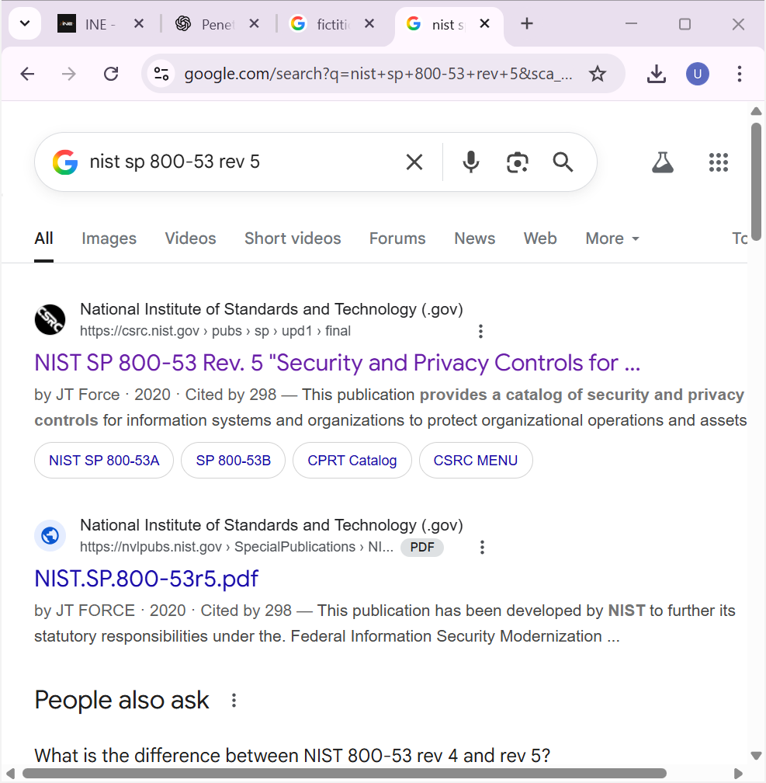

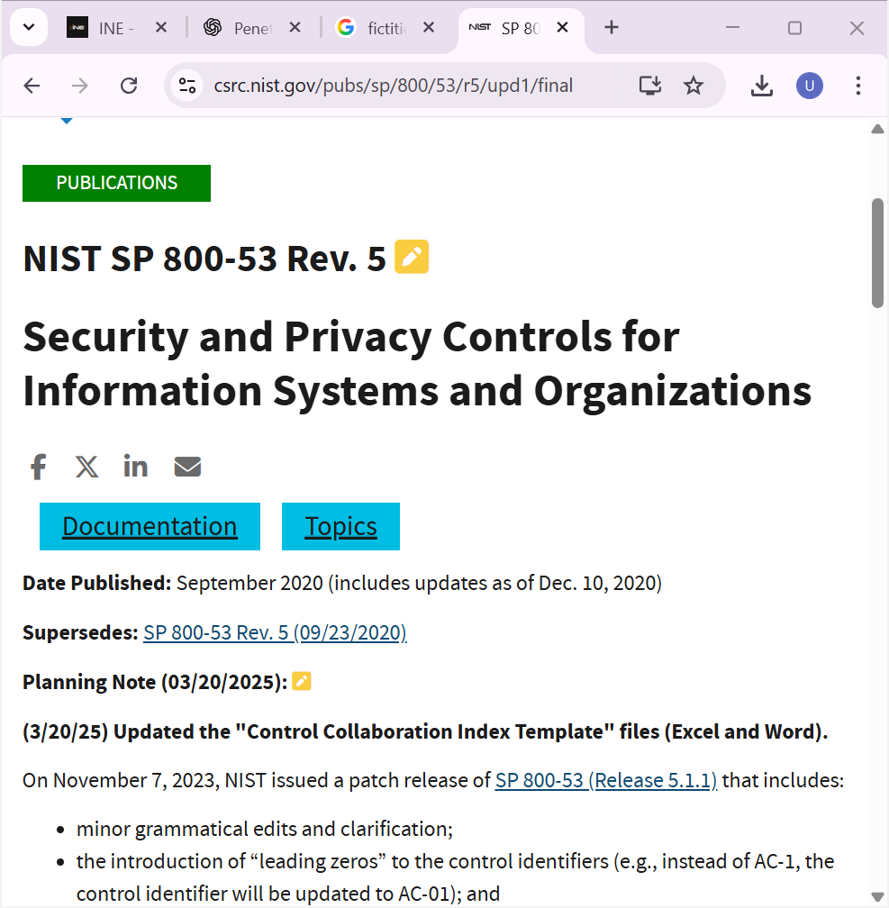

In its document there is all the point and on the baseline of these we make our own point according to our company security respectively.

